**NAME: ROHAN DHOYDA**

**Q1 a) Graph the closing price vs. the date with an ordinary line graph. If you use**

**Tableau, you need to right-click on the Date and choose Exact Date from the**

**dropdown menu so that it uses the full date with "day".**

**Q1 b) Graph the Volume vs. the exact Date as in the last part with a bar graph.**

**Q1 c) Create a scatterplot that graphs the Volume on the x-axis and the daily price**

**range on the y-axis. You will need to create an additional column that**

**contains the "range" of the prices for the day as the difference between the**

**fields High and Low.**

**Range = High – Low**

**Tableau can do it with a Calculated Field. In R you can do it by making a**

**new column equal to the result from subtracting the two columns. In Tableau,**

**to get a scatter plot, you will need to right click on both the Range and Volume**

**entries in graph and change them to "Dimensions".**

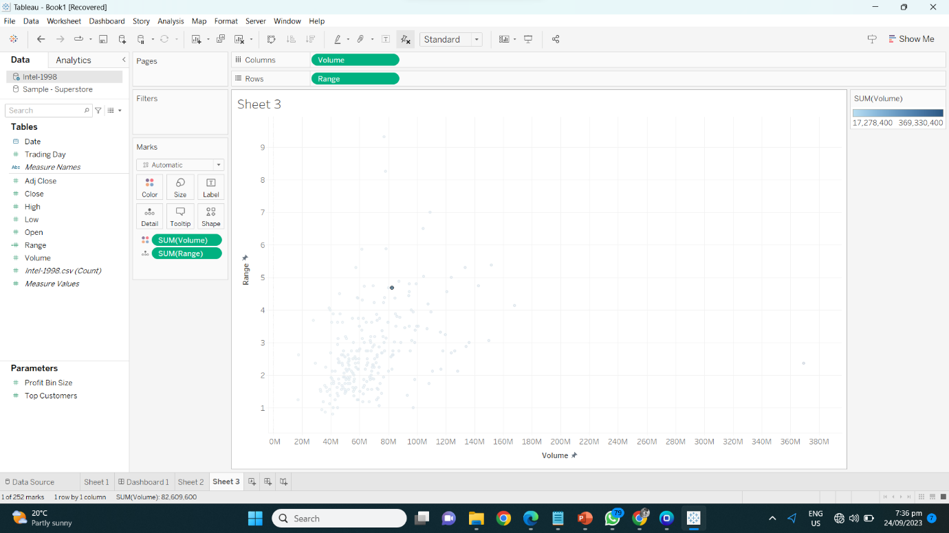

**Q2 a)** **A treemap based on Price with a main subdivision for the Make of the car and**

**a minor subdivision based on the Model. Because each row of the data file**

**represents a single car but each box in the treemap represents all the cars with**

**a given make and model, pay very close attention to what kind of aggregation**

**is being used.**

**Q2 b) A packed bubble chart of the same type.**

**Q2 c) Write a short paragraph discussing the differences between the two plots.**

**Describe for each something that is displayed more clearly than with the other.**

**Ans:** When evaluating the above plots I found that the Treemap is a prior choice than the Bubble chart. The Treemap, which is organized with "Make" as the primary subdivision and "Model" as the minor subdivision, excels at showing how prices are distributed among various automobile makers and models. This hierarchical structure makes it easy to grasp how particular combinations affect the final cost. It works well to show which automobile brands and models have the highest total costs, which makes it very helpful for figuring out the best possible combinations. Whereas, The packed bubble chart, on the other hand, which is likewise divided into "Make" and "Model," provides a more aesthetically pleasing representation. It makes use of bubble size to quickly communicate relative cost. This visual method gives a rapid, intuitive picture of how much different makes and models cost. However, it might be less accurate for precise comparisons.

**Q2 d) Showing with color the number of cars (Number of Records) of each Type sold**

**by each Make. Explain at least one observation about that data that this chart**

**makes it easy to see.**

**Q3 a) One chart that graphs the population growth over the years for the individual**

**reservations.**

**Q3 b) One that graphs the total reservation population for each year, subdivided**

**among the different reservations. The difference between this and (a) is that in**

**(b) we are not looking only at each population individually but at the growth**

**of the total population of all of them together, then subdivided by the**

**reservations.**

**Q4 a) Explain what we mean by ‘pre-attentive’ attributes. Are these as**

**effectively recognized by human perception when they are used in**

**combinations?**

**Ans:** When pre-attentive qualities are combined, they can support one another and produce more complex visual clues. The most important data points, for instance, can be considerably more easily identified when color and size are combined. To avoid cognitive overload and make it more difficult for viewers to understand the data, it's crucial to maintain a balance and avoid overstuffing a visualization with attributes. In conclusion, merging pre-attentive qualities can improve visual communication, but doing so necessitates thorough design consideration to assure efficacy.

**Q4 b) Use Weber’s Law to explain why it is important to include 0 in the**

**the numerical axis of a bar chart.**

**Ans:** According to Weber's Law, a cornerstone of psychology, our capacity to distinguish between two stimuli is proportional to their initial intensity. This law emphasizes how crucial it is to include "0" on the numerical axis when used with bar charts. The relative differences between bars may be misinterpreted if the axis is missing the number "0". Small differences may seem disproportionately important, to use Weber's terminology, causing a misunderstanding of the data. The inclusion of "0" serves as a critical reference point and enables viewers to discern the relative size of values represented by the bars. Practically speaking, leaving out the number "0" can lead to misunderstandings, increasing perceived disparities, and possibly distorting decision-making. Bar charts preserve the integrity of the data by following Weber's Law and including "0,"

**Q5 a) Comparing Cell Phone Companies of what type of plans they have**

The code creates a grouped bar chart in R using ggplot2 to compare the costs of various carriers' cell phone plans. The groups of bars that make up each company are colored according to the amount of data (measured in GB) that is included in the plans. The chart has a title, x, and y axis names, and a caption for the colors of the data amounts. Each company's bars are placed side by side, and the chart has a minimalist design for a polished appearance. This arrangement makes it simple to compare rates between businesses and data plan sizes. As evident from the chart, Sprint Cell Phone Company offers a 40 GB data plan priced at $100, a unique offering not found with AT&T. AT&T's highest-tier plan maxes out at 30 GB and is among the most expensive among the three companies. Verizon's plans extend up to 24 GB but are priced higher than $100, whereas Sprint offers a comparable 24 GB plan for approximately $75.The entry-level plan is a 1 GB package available from both AT&T and Sprint, with Verizon starting at 2 GB, mirroring AT&T's price. AT&T and Sprint also provide plans at 3 GB, 10 GB, and 16 GB, while Verizon offers plans at 4 GB, 8 GB, 10 GB, and 16 GB. In summary, Sprint stands out as the most budget-friendly option compared to AT&T and Verizon, offering competitive pricing across various data plan sizes.

**Q5 b) Relationship between Price and Data Bandwidth**

The code creates a scatterplot using ggplot2 in R to show the association between data bandwidth (x-axis) and cell phone plan costs (y-axis) for different companies (color-coded points). It provides for easy comparison of plan price and data offerings and is titled "Relationship Between Price and Data Bandwidth". As you can see from the graph, Sprint delivers more bandwidth at a cheaper cost than AT&T, which has the highest pricing among the other providers, and Verizon offers less bandwidth than 30 gb while AT&T charge the same for that plan.